**Topic**: State of the Sun

**Rationale**: Providing the user an opportunity to explore the “good” and the “bad” side of the sun across the US at a state-level. The primary focus is the “good”: solar project completion by state and associated metrics, including visualization of correlations by metric (e.g., system size vs. cost). The “bad” component is a review of skin cancer rates by state.

**GitHub repository**: https://github.com/sheygarga/Project2Group1

**Datasets**

1. National Renewable Energy Laboratory (NREL) OpenPV project. Solar installation metrics by state (e.g., project count, capacity, size). <https://developer.nrel.gov/docs/solar/openpv/> Determining whether to use JSON format or csv.

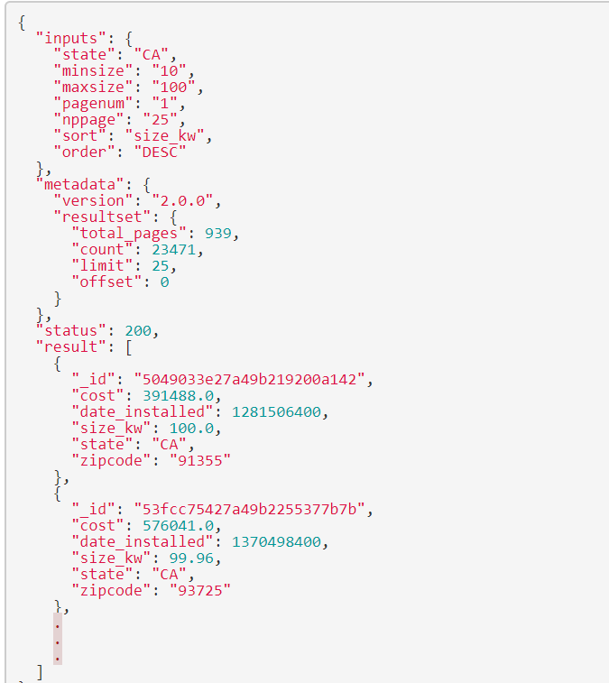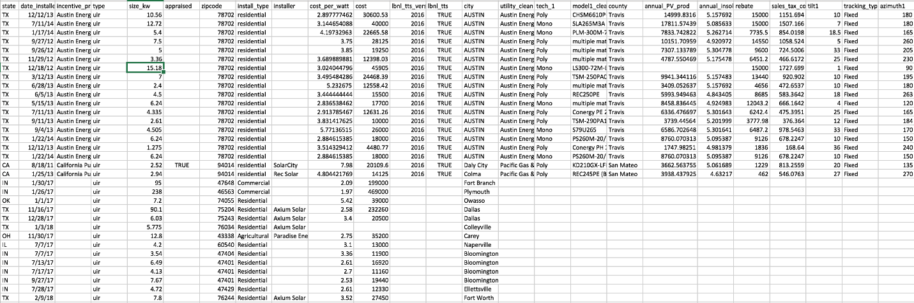

1. Energy Information Agency (EIA): Average electricity price by state and end use sector. <https://www.eia.gov/electricity/monthly/epm_table_grapher.php?t=epmt_5_6_a>

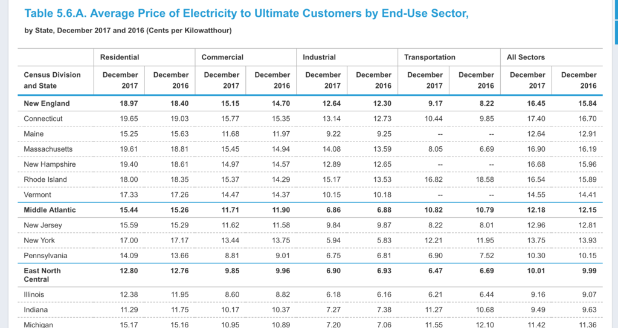

1. 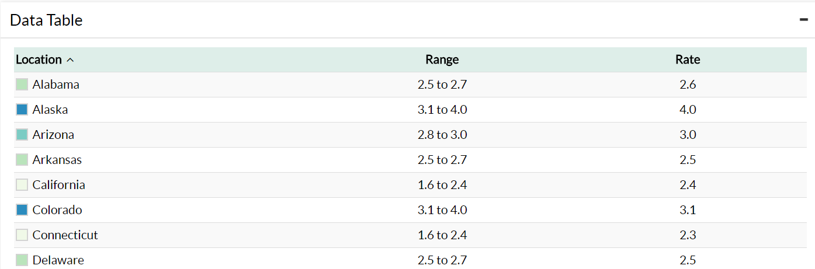Center for Disease Control and Prevention (CDC): Skin cancer rates and melanoma mortality rates by state. <https://www.cdc.gov/cancer/skin/statistics/state.htm>

**Inspiring Visualizations**

Layered heat map (intent is to provide layer control via Leaflet)

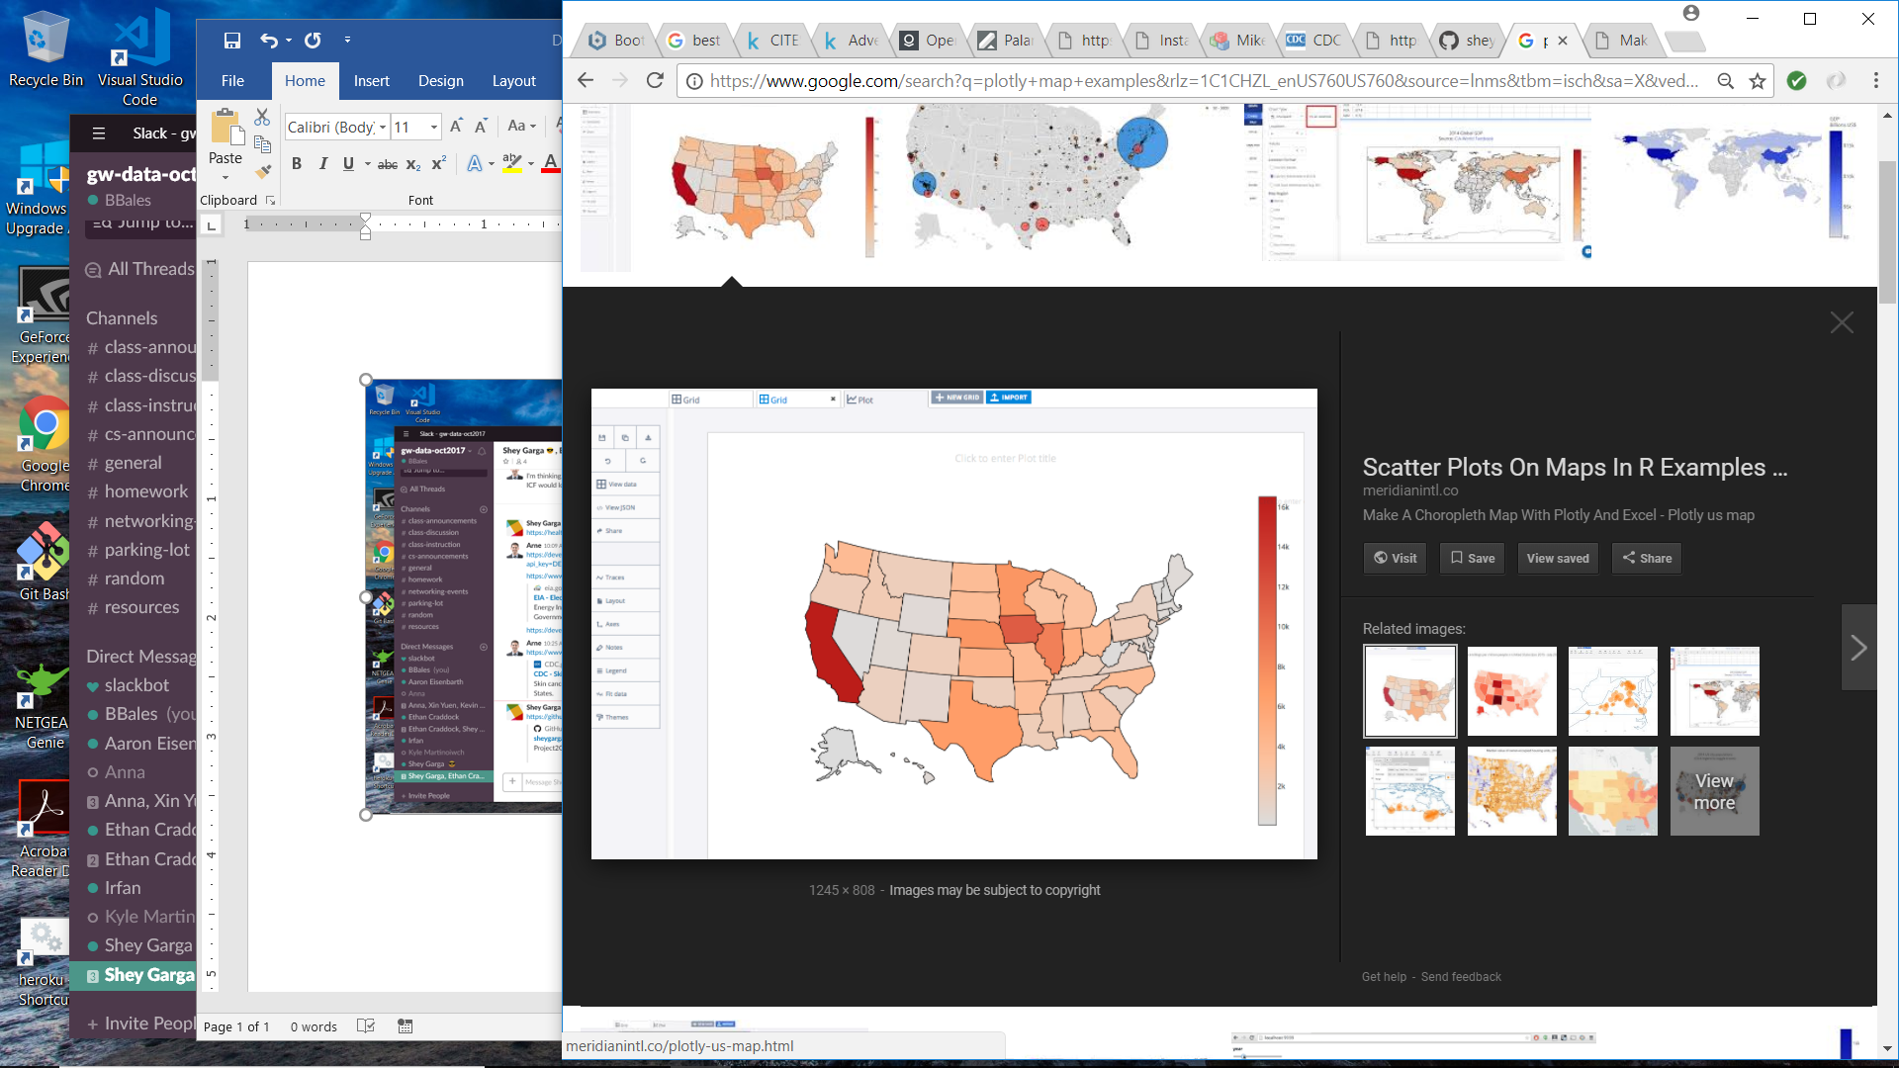

Scatterplot (via Plotly)

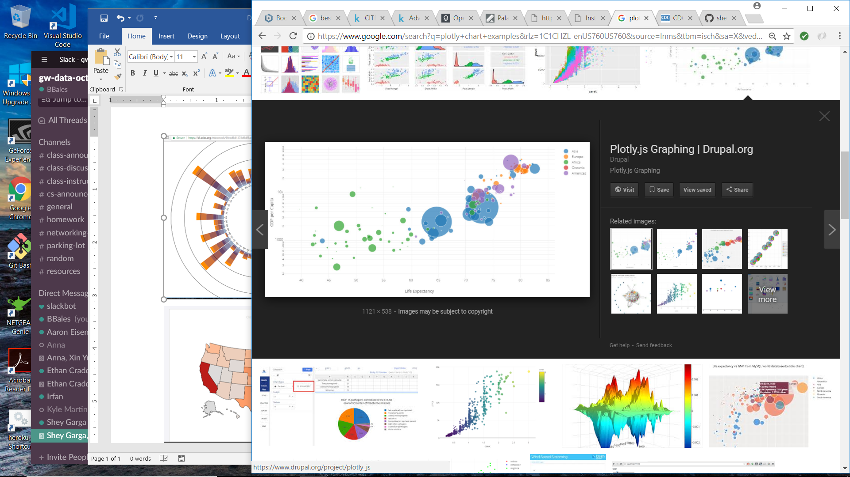

“Sun-inspired” radial stacked bar:

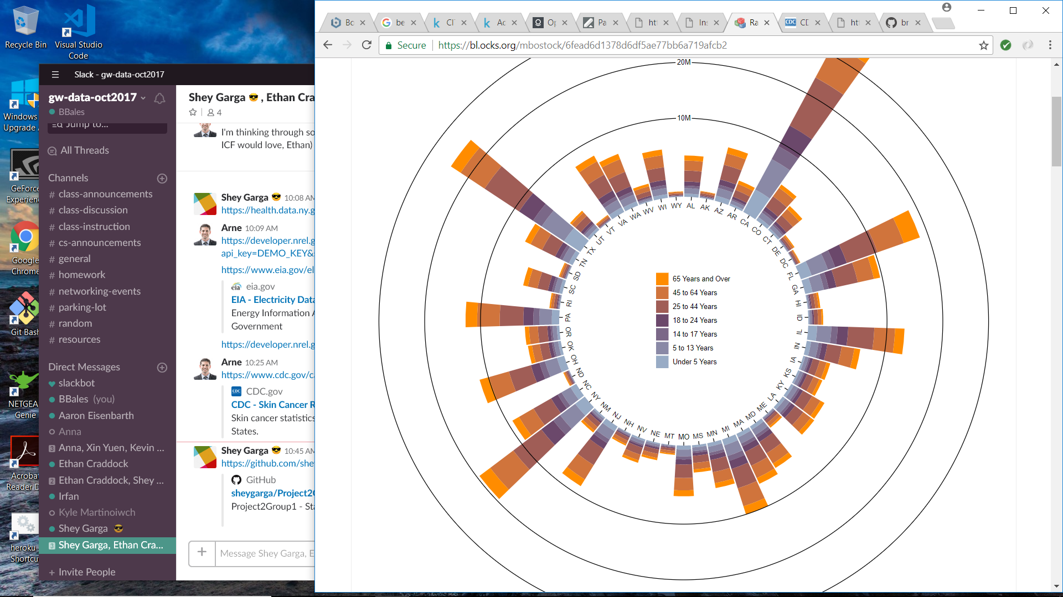

**Final Design Sketch**

We hope to put together a main page that is dashboard style in layout, with a basic navbar, more in depth side bar, and relatively large core visualization and data display area. The side bar will allow the user to select the visualization to appear in the viewing area and some data switch cases. We will also have a couple of additional pages managed in the navbar to show large data tables and other deep detail information.